

**TRANSITION & MATHEMATICS EDUCATION**

A half day conference for all mathematics education practitioners in schools and colleges and everyone involved in researching mathematics education

**Friday 2 March 2012 from 12:30 to 6:30pm**

Transition is a challenge not only for pupils and students moving from one stage of education to the next, but also for teachers, tutors and lecturers. Teachers and lecturers need to develop practices that support students both before and during transition. The problems arise when mathematics is constituted in different ways to those that are familiar to the pupils/students. This may be because mathematics is taught in a ‘different way’ in the different phases but also because mathematics can be taught as a subject in its own right as well as being taught to support learning in a different topic.

The purpose of the first part of this conference is to enable practitioners to share their research into transition and mathematics education with other delegates in a friendly and supportive environment. This will be followed by a more in-depth session looking at the impact of academic work (5:00pm to 6:30pm).

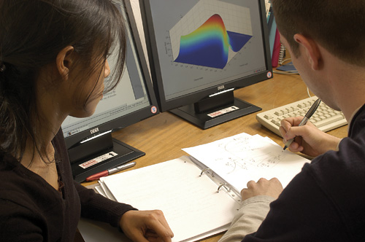

The event is being organised by the STEM Education Research Team at the University of Manchester and will be hosted at Chancellors Hotel and Conference Centre, Chancellors Way,  Moseley Road, Fallowfield, Manchester M14 6NN (free car parking is available).

Registration for this event is FREE (including lunch and teas/coffees). However, please note that places are limited and are allocated on a ‘first come, first served’ basis. Please also note that by registering for this event, you agree that if you register but fail to attend without providing 72 hours prior written notice to, a £40 cancellation charge will be made to your institution.

In order to register for this event, please contact Diane Harris [di.harris@manchester.ac.uk](mailto:di.harris@manchester.ac.uk). Practitioners, if you are interested in presenting some research of your own during the first part of the conference then please send a 200 word outline of your work to Diane. The closing date is Friday **24 February 2012.**

If you wish to book an evening meal or overnight accommodation at Chancellors at very reasonable rates, we can provide contact information.

**We are grateful to the ESRC for funding this conference as part of the project: Promoting Participation and Engagement in Post-Compulsory Mathematics Education for STEM (RES-189-25-0235)**

For conference updates and more information about the project, please go to [www.transmaths.org](http://www.transmaths.org)